Roanoke, Virginia: England’s Lost Colony- Theory 1
In 1587, a group of 115 Europeans traveled to the New World in order to establish the first English Colony. Explorer Sir Walter Raleigh had been granted a charter (a document granting the owner possession but still serving a king or queen) to land in Virginia (but the region today is actually in North Carolina). The group of Europeans, led by a man named John White, settled in the colony of Roanoke. The colony’s early claim to fame was being home to the first English baby born in the New World (a girl named Virginia Dare, granddaughter of John White), but life became hard quickly. Low food supplies became problematic and there was the uncertainty of Native American attacks. This situation led John White to return to England to get help for the colonies in late 1587. However, due to an ongoing war with the Spanish (the Anglo-Spanish War), White could not get to the colonists until 1590. When he returned, all of the colonists had disappeared and the colony itself was abandoned. What happened to the lost colony?
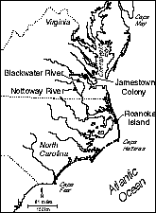
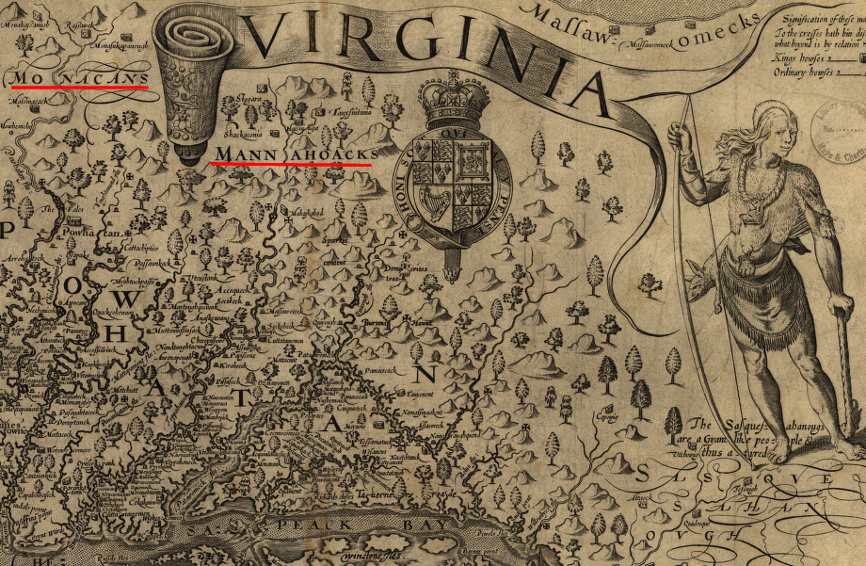
Indian attacks were not entirely rare events in the colony. In 1587, Natives killed a colonist named George Howe while he was searching for crabs alone. Despite the fact that some tribes in the region were friendly to the settlers, theories suggest that political shifts in the area resulted in the rise of Native American tribes who were not friendly with the Europeans. After years of Europeans claiming land that belonged to the Native population, the spread of disease and the enslavement of local tribe members, some scholars believe that there was a Native American attack on the Roanoke colony. The attack resulted in either the kidnapping or death of all the colonists.

Roanoke, Virginia: England’s Lost Colony- Theory 2
In In 1587, a group of 115 Europeans traveled to the New World in order to establish the first English Colony. Explorer Sir Walter Raleigh had been granted a charter (a document granting the owner possession but still serving a king or queen) to land in Virginia (but the region today is actually in North Carolina). The group of Europeans, led by a man named John White, settled in the colony of Roanoke. The colony’s early claim to fame was being home to the first English baby born in the New World (a girl named Virginia Dare, granddaughter of John White), but life became hard quickly. Low food supplies became problematic and there was the uncertainty of Native American attacks. This situation led John White to return to England to get help for the colonies in late 1587. However, due to an ongoing war with the Spanish (the Anglo-Spanish War), White could not get to the colonists until 1590. When he returned, all of the colonists had disappeared and the colony itself was abandoned. What happened to the lost colony?
Before leaving for England, John White had instructed the colonists to carve a cross into a tree if they were forced to leave the colony. However, when White returned, he found, not a cross, but rather the word “Croatoan” carved into a tree and the letters “Cro-” carved into a fencepost. The lack of a cross suggests that the colonists moved willingly, but to where? Croatoan is believed to be another name for Hatteras Island, located near the Roanoke Colony. The Native American tribe on the Island, the Croatan tribe, was one of the few tribes on peaceful terms with Europeans in the region. Some scholars believe the settlers travelled to Hatteras Island and integrated into Croatan society. Studies have even linked old ring found on the island to one of the Roanoke settlers. However, when White decided to go to the island, a massive storm prevented the search and the colonists were never found. Unfortunately, by 1597, the Croatan tribe suffered from several epidemics including an outbreak of smallpox resulting in the extinction of the tribe due to disease.
"I greatly joyed that I had safely found a certain token of their safe being at Croatoan… the savages of the island our friends."
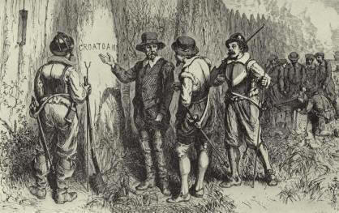
-John White, 1590
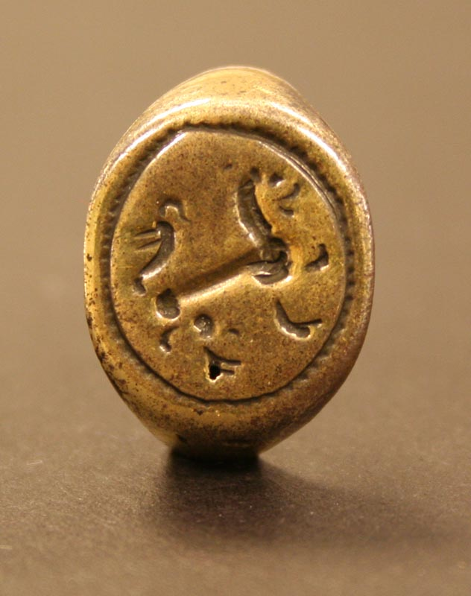

Roanoke, Virginia: England’s Lost Colony- Theory 3
In 1587, a group of 115 Europeans traveled to the New World in order to establish the first English Colony. Explorer Sir Walter Raleigh had been granted a charter (a document granting the owner possession but still serving a king or queen) to land in Virginia (but the region today is actually in North Carolina). The group of Europeans, led by a man named John White, settled in the colony of Roanoke. The colony’s early claim to fame was being home to the first English baby born in the New World (a girl named Virginia Dare, granddaughter of John White), but life became hard quickly. Low food supplies became problematic and there was the uncertainty of Native American attacks. This situation led John White to return to England to get help for the colonies in late 1587. However, due to an ongoing war with the Spanish (the Anglo-Spanish War), White could not get to the colonists until 1590. When he returned, all of the colonists had disappeared and the colony itself was abandoned. What happened to the lost colony?
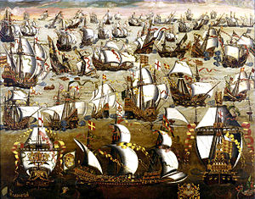
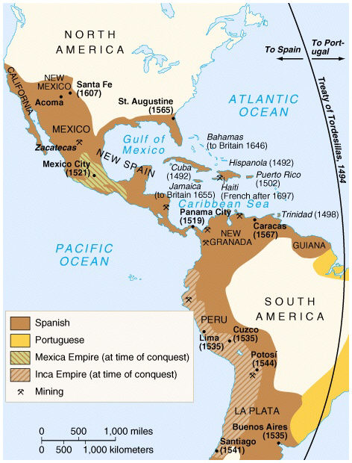
In the 1560s, the Spanish destroyed Fort Charles in what is today South Carolina. The fort was controlled by the French and everyone who lived there was killed by the powerful Spaniards who invaded. Spain was the most powerful empire in the World and had the most powerful navy, the Spanish Armada. It is possible that the Spanish, who had control of the southern potion of the North America, wanted to further expand north and came across the English colony of Roanoke. Spain and England were in the midst of fighting a war for land and sea supremacy at this time and the Spanish would not have simply let the colony survive. Despite the fact that the armada itself was destroyed by a powerful storm during a planned invasion of England in 1588, Spain was still strong enough to conquer Roanoke if it desired to.

Roanoke, Virginia: England’s Lost Colony- Theory 4
In 1587, a group of 115 Europeans traveled to the New World in order to establish the first English Colony. Explorer Sir Walter Raleigh had been granted a charter (a document granting the owner possession but still serving a king or queen) to land in Virginia (but the region today is actually in North Carolina). The group of Europeans, led by a man named John White, settled in the colony of Roanoke. The colony’s early claim to fame was being home to the first English baby born in the New World (a girl named Virginia Dare, granddaughter of John White), but life became hard quickly. Low food supplies became problematic and there was the uncertainty of Native American attacks. This situation led John White to return to England to get help for the colonies in late 1587. However, due to an ongoing war with the Spanish (the Anglo-Spanish War), White could not get to the colonists until 1590. When he returned, all of the colonists had disappeared and the colony itself was abandoned. What happened to the lost colony?
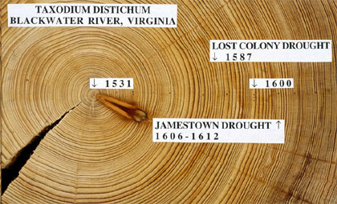
Studies in climatology (climate and weather) have suggested that a drought may have caused the disappearance of the colony. Using evidence from the cores of 800-year old Cypress trees, researchers have suggested that during the years 1587, 1588 and 1589, the region in which Roanoke was located experienced the most severe drought in the entire 800-year sample. This, along with the fact that the colonists were not used to growing European crops in New World soil, leads one to believe that the lack of water and food in Roanoke was enough to spell doom for the colonists who had little to eat and drink.

